



**Department of Computer Science**

**Quaid-e-Azam University, Islamabad**

**Assignment 6**

**Student Course Registration System**

Prepared by:

**HURR MEHDI**

**M. SEHAL BILAL**

**M. ASAD**

**ZOHAIB AHMED (Leader)**

Submitted to:

**DR. ONAIZA MAQBOOL**

15 April 2025

|  |  |
| --- | --- |
| 3-tiered architectural dIAGRAM | **Student Course Registration System** |
| Created by | Group 8 |
| Date Created | 15-04-2025 |

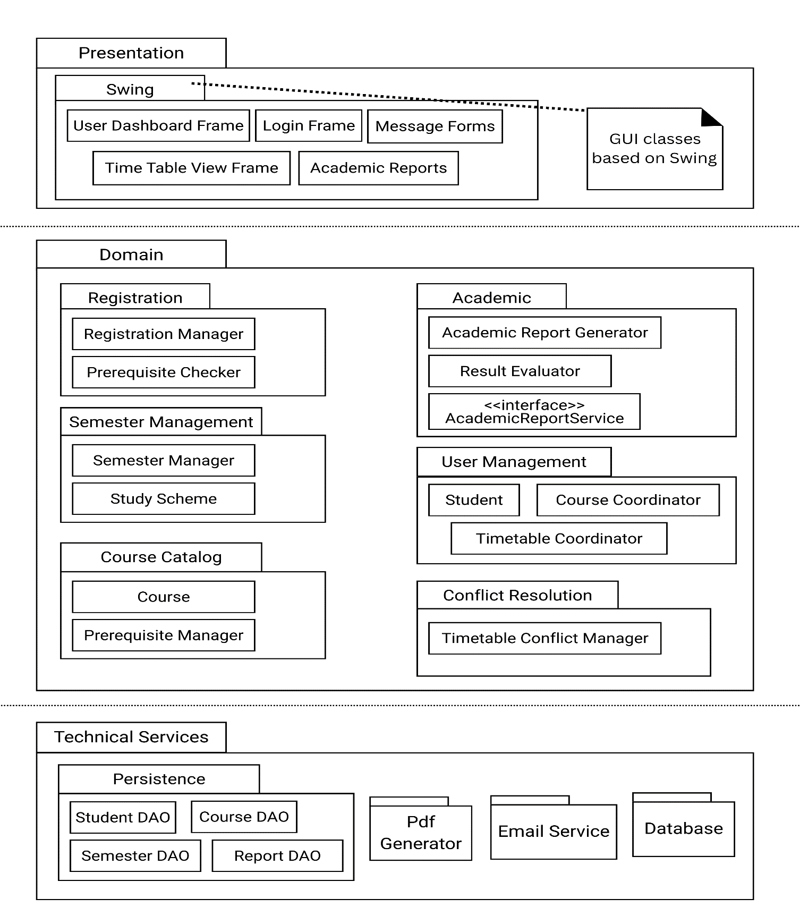

## Architectural Diagram Description

*The architecture follows a three-tiered design: Presentation, Domain, and Technical Services, separating concerns between UI, business logic, and infrastructure. This improves modularity, maintainability, and scalability of the desktop-based application.*

**1. Presentation Layer**

*This tier is responsible for user interaction. It contains all graphical interface components developed using Java Swing, allowing different user roles (Student, Course Coordinator, Timetable Coordinator) to interact with the system.*

**Components:**

* *Login Frame: Provides authentication interface for all users.*
* *User Dashboard Frame: Home screen after login tailored to each user’s role.*
* *Time Table View Frame: Enables students and coordinators to view course schedules.*
* *Academic Reports: Visual representation of academic performance.*
* *Message Forms: Displays system messages, confirmations, and alerts.*

*All components here are GUI classes based on Swing, and directly interface with the domain layer to trigger business logic.*

**2. Domain Layer**

*This is the core of the application where all the main processing happens. It is organized into packages reflecting key business processes:*

**Registration**

* *Registration Manager: Controls the student course registration process.*
* *Prerequisite Checker: Validates course prerequisites before enrollment.*

**Academic**

* *Academic Report Generator: Generates detailed performance reports for students.*
* *Result Evaluator: Determines pass/fail status and calculates GPA.*
* *<<interface>> AcademicReportService*

**Semester Management**

* *Semester Manager: Manages semester creation and details.*
* *Study Scheme: Represents curriculum structure including courses and prerequisites.*

**User Management**

* *Student: Business entity representing student data.*
* *Course Coordinator: Manages offered courses and study schemes.*
* *Timetable Coordinator: Handles conflict detection and class scheduling.*

**Course Catalog**

* *Course: Core entity for course information.*
* *Prerequisite Manager: Maintains and enforces prerequisite chains.*

**Conflict Resolution**

* *Timetable Conflict Manager: Detects and resolves timetable clashes.*

**3. Technical Services Layer**

*This tier provides infrastructure support like data storage, reporting, and communication.*

**Persistence**

* *Student DAO, Semester DAO, Course DAO, Report DAO: Data Access Objects responsible for interacting with the underlying database for each entity.*

**Utilities**

* *PDF Generator: Creates downloadable reports.*
* *Email Service: Sends confirmation emails or notifications.*

**Database**

* *Centralized data repository accessed via DAOs.*

**Layer Interaction Summary**

* *The Presentation Layer invokes services in the Domain Layer to perform operations.*
* *The Domain Layer enforces all rules and logic, and accesses the Technical Services Layer for storage, report generation, and communication.*
* *Communication flows top to bottom (UI → Domain → Services) and uses interfaces to promote abstraction and flexibility.*